Annotation of road signs using machine learning for autonomous vehicles
College Name: SK Somaiya College of Arts, Science and Commerce Course Name: MSc (IT) -part I

Shubhangi Jagdish Shinde
Abstract
As we are in the 21st century and we are living in an autonomous world, the autonomous vehicle is one step ahead and I think this invention will help us a lot.
So according to my topic the interpretation of road signs using machine learning for autonomous vehicles is the important and most basic requirement for this autonomous vehicle.
It also includes the annotation of road signs, which were used by the driver to drive the car that instructed the driver and followed the rules for the safety of human transport.
Now this signal is going to help for autonomous driving and it will act like a trainer or as a guide for a working road.
Key term
Autonomous, Machine, Instructor, Annotation
Introduction
The mention of road sign using machine learning for autonomous vehicle subject is a very necessary topic for the development of autonomous vehicle. Subject wise the paper will include steps for machine learning and will include a purely sign recognition process.

History
By 1958, General Motors had made the concept a reality. The front end of the car was embedded with a sensor called a pick-up coil that can detect the current flowing through the wire in the road. The current can be manipulated to ask the vehicle to move the steering wheel left or right. In 1977, the Japanese improved the idea, using a camera system that relayed data to computers to process road images.
Reforms from the Germans came a decade later as the Vohmer, a camera equipped with cameras that can safely drive at speeds up to 56 mph. As technology improved, vehicles gained the ability to self-drive to detect and react to their environments.
How it works
As we are working on annotations for autonomous vehicles, they need to preprocess the data and this data will be detected by the system using machine learning algorithms and after that only the system can recognize the data because the annotations in it Includes 3 stages for.
1.Pre Processing
2.Detection
3.recognition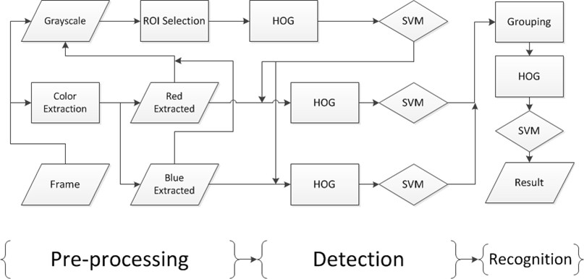

1.Pre Processing
Color and shape information are commonly used as signs features. Road signs throughout the country are similar to each other, there can be differences in language, color and sometimes even size but are easily recognizable. Since we collect those signals from drive files and create a database of various road signs.
We perform color extraction using the adaptive threshold method. Image acquisition is performed using a webcam that attaches to the Raspberry Pi via a USB 2 connector (this is a low-cost, credit-card-sized computer that plugs into a computer monitor or TV, and a standard keyboard And uses the mouse). Image received. The BGR format is (blue, green, red) - specific to the bitmap format. The image is then transferred to the OpenCV module for further processing.
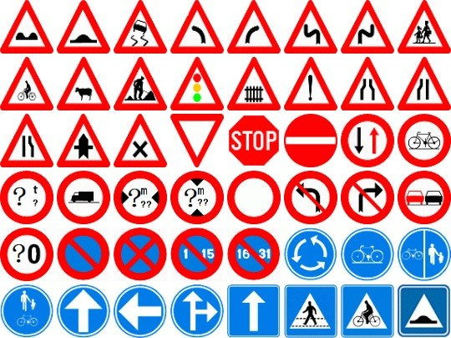

2.Detection of signs
Transmission of a pre-processed image (including known objects) is done for the vehicle's smartphone using the Raspberry Pi's built-in Wi-Fi module. The system implements this by creating a server that broadcasts a live video feed. This is done on port 5000. The server's IP address is transmitted to the vehicle application at connection time.
This detection process is done by means where the signals are detected by the human eye and they make a bound box for it on the living file and then they need to label that name with the correct name and This data will be stored in the database on the backend.
During runtime the system processes the image from the webcam and then performs segmentation algorithms on the system frame. The same segmentation algorithm is used for training and detection.
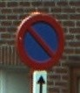
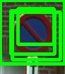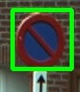
Grouping detection of sign
3.Traffic sign recognition
Since pre-processing and HOG (a histogram of orientated gradients used in computer vision and image processing for the purpose of object detection) algorithms are complex and in this section we require extensive computation, which we use GPU-based Let's describe acceleration. This specific point of operation for pre-processing is suitable for GPU implementation. HOG computing is more complex, and we develop several techniques to handle it. The OpenCV library contains a GPU version of HOG that speeds up computation compared to the CPU version. The HOG features need to be computed across many different scaling levels of the original image, and the gaps between levels can be reduced or eliminated.
Once each level of input data is prepared, there is no data dependency during HOG calculation between different levels. In the OpenCV implementation, a stall is kept at each level until the previous level is calculated to ensure data synchronization between the kernels.
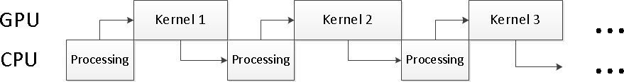
Like the wise we significantly reduce the interval between levels and thus improve the efficiency of HOG computation
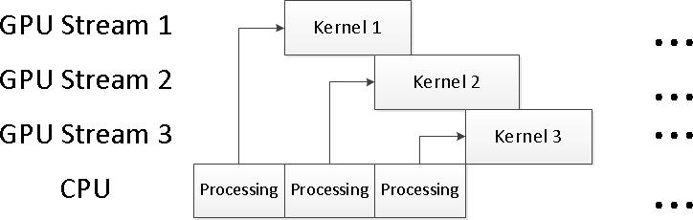

Future Scope
Companies in the automotive industry are going to have a period of adjustment and pressure to keep pace with the latest technology in terms of potential impacts such as taxi
Finally, industry players will develop and react as they have in the past.
From an aftermarket perspective, the increase in the number of autonomous vehicles may increase interest in advanced video technology such as additional car customization to entertain passengers.
I think that as a society we will be adjusted for change in order to adopt autonomous vehicles.
While some are predicting that we will see an influx of these vehicles over the next five to ten years, I believe there is a more realistic prediction within
Conclusion:
Finally, Autonomous vehicle is a recent technological development that has potential to change the human requirements and It has potential to change the world into autonomous world and It will also affect on users ,business , Natural resources .It will reduce the men power by spending less on maintenance.
Reference:
1. Research on traffic signal recognition based on intensive learning
(Published in 2016 16th International Symposium on Communications and Information Technology (ISCIT))

2. Traffic Signs Recognition and Classification (7th International Conference on Pattern Recognition Applications and Methods) based on Deep Feature Learning.
3. U.S. Deep Learning Approach for Traffic Sign Recognition (Published in)
Proceedings of the 2019 Third International Conference on ICDLT 2019 Deep Learning Technologies)
4. J. P. C. Advanced driver assistance system based on computer vision using Pascal, identification, identification and tracking of road signs [Ph.D. Thesis], Charles III University of Madrid, Getafe, Spain, 2009.
5. a. Ruta, YM Li, and XH Liu, "Detection, Tracking and Recognition of Traffic Signals from Video Inputs," in Proceedings of the 11th International IEEE Conference on Intelligent Transportation Systems (ICS '08), 11th 55-60. , IEEE, Beijing, China, December 2008
6. L. Priese and V. Rehrman, "On Hierarchical Color Segmentation and Applications," in Proceedings of the IEEE Computer Society Conference on Computer Vision and Pattern Recognition (CVPR '93), pp. 633–634, IEEE, New York. NY, USA, June 1993
7. a. Nikornov, p. Yakimov, M. Petrov, Traffic Sign Detection Color Shape Regular Expressions on GPUs, using Vigigrap IMTA-4, Paper 8 (2013).
8.R. Bellerossi, p. Faucher, J.P. Tarell, b. Sohilian, p. Charbonnier, n. Sign in paproditis road sign image
A case study, 20th International Conference on Pattern Recognition (ICPR) (2010), pp. 484-488

